40) Aim: To Design Push Down Automata to represent the language L ={W/W belongs to (a+b)\* and na(w)=nb(w) where na(w)=Number of a’s in w, nb(w)=Number of b’s in w.

Diagram:

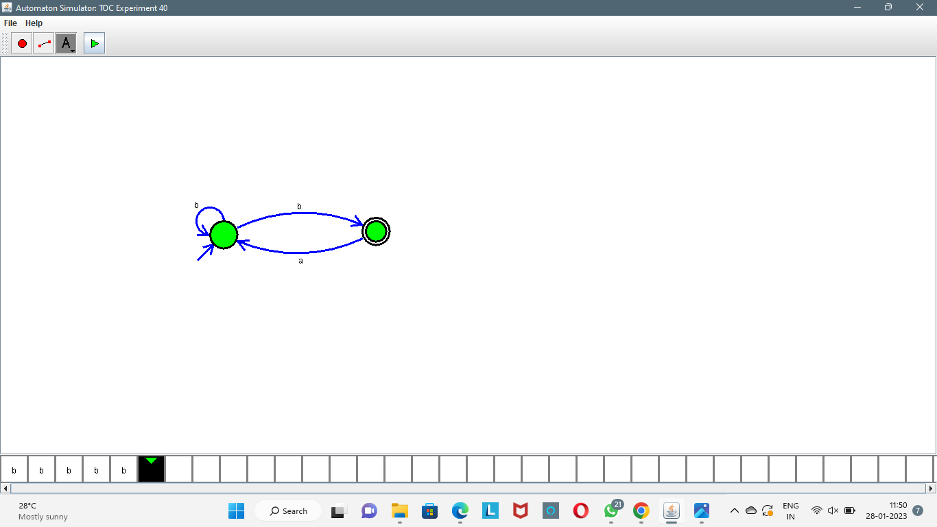

Result:

Successfully executed Push Down Automata to represent the language L ={W/W belongs to (a+b)\* and na(w)=nb(w) where na(w)=Number of a’s in w, nb(w)=Number of b’s in w.